**MSCC 630 – Enterprise Architecture – Final Exam**

**B. Lawler, Instructor. June 2017**

Download this document, add your replies after the questions and submit the completed document (these questions and your answers) into drop box. Use the point values to guide the length and depth of your replies – questions worth more points should get more of your attention. Suggested lengths below are for single space replies and only guidelines - not hard requirements.

**Question #1** - Make a comparison of two Enterprise Architecture frameworks. Pick your two from Zachman, TOGAF, FEAF or DoDAF. Provide and use 3-4 attributes for your basis of comparison. Use strong comparison and contrasting statements – e.g., “Framework A differs from Framework B in that…” or “Both frameworks are similar in how…”. Responding in a table format is fine. *(10 points, ~ ½ page)*

**Answer # 1:**

TOGAF 9.1 was developed by the Open Group to facilitate a framework for the design, building and evaluation of EA. Similarly, the FEAF v2 was issued by US CIO council to facilitate shared development for common US federal processes, encouraging interoperability and sharing of information between federal agencies.

Both the TOGAF and FEAFv2 utilize similar views that represent different perspectives of the system model. The Federal Enterprise Architectural Framework includes planners view, model owners view, model designers view, builders view and the subcontractors view which facilitate data architecture (what), applications architecture(how) and technology architecture(where). The Open Group Architectural Framework includes the business architecture view, information systems view and the technical architecture view which facilitate decision making guidance (how) and IT resource utilization guidance(who).

FEAFv2 is similar to TOGAF as it provides a vocabulary to describe IT assets. In FEAF v2 the consolidated reference model is similar to the TOGAF’s architectural content metamodel which helps describe IT assets using a common vocabulary.

TOGAF is different than FEAF v2 as it includes the Architecture Development Method(ADM) which is a methodology to develop iterations of actionable EA. In addition, artifacts in TOGAF are organized into the enterprise continuum- a repository for governance. The FEAFv2 does in comparison does not propose a methodology to develop EA artifacts nor does it propose a repository for governance.

FEAFv2 is also places additional emphasis on performance and security. In FEAF performance reports are mandatory unlike in TOGAF.

**Question #2** - Provide an annotated bibliography entry for the Ross (2004) reading on the strategic benefits from EA. Focus your annotation on the applicability of the key points in this reading – who should read this article, what the purported benefits are and how are they obtained, conditions or constraints on success, etc. In your critique, incorporate information you found out on your own about Ross’ work by referring to work from someone other than Ross. In your critique, also refer to at least one of the other primary sources for the course (Land, Minoli or Bernard) relative to this topic of strategic benefits. *(10 points, ~ ½ page)*

**Answer # 2:**

Ross, J.W. (2004). Generating strategic benefit from enterprise architecture. *Center for Information Systems Research, Volume* *IV(3A)*

Ross states that actionable EA helps achieve strategic business benefits. Strategic business benefits in turn secure greater profits for the enterprise. Ross identifies four strategic benefits of operational excellence, customer intimacy, product/service innovation and strategic agility. Ross notes that firms that achieve greater strategic business benefits are ones that have three main characteristics of greater senior management involvement, architecture built into project methodology and greater architecture maturity. Ross also identifies five mechanisms that help attain the three characteristics. These mechanisms are clear definition of EA guiding principles, proven business cases for IT investments, an active IT steering committee, a succinct graphic of the architecture and a technology research and adoption process.

In summary Ross identifies the importance of stakeholders to the enterprise, the need for a documentation method and an active governance program that fosters greater architectural maturity. Likewise, Bernard in his work identifies that technology is an enabler of business and should be managed strategically. Bernard’s EA cube framework similarly identifies strategic initiatives, business services, information flows and technology infrastructure in relation to security, standards and skills.

This article was made possible via CISR which is sponsored by a collection of commercial enterprises across energy, pharmaceutical, finance and automotive sectors.

**Question #3** - Reflect on the information technologies and business practices present at the time of the Zachman (1987) article. Describe (1) a contemporary business practice that on while very different from the ‘80s still faces similar fundamental challenges to what started the EA movement and would benefit from an EA approach…..and (2) a contemporary technology that while also very different from the technology of the 1980s faces the similar challenges and an organization would benefit by using EA to manage that technology. *(10 points, ½ page)*

**Answer #3:**

The Zachman framework combined strategy with architecture to create the field of Enterprise Architecture in the 1980s. The technology focused around business process management changed dynamically in tandem with the Enterprise Architecture principles. In 1980s business process management technologies were monolithic and often deployed as a custom made single application. These workflow management systems defined, managed and executed business processes through an integration of process engineering, work item processing and execution log analysis. (Weber, 2016) The business had to rewrite modules when it came to extending coverage or enabling new business units. The business did not have a strategy to tackle expansion, application development was not strategic and integration between distinct enterprise information systems was ad hoc.

Since then in contemporary IT world, we have seen the rise of service based business process management technologies. These technologies are loosely coupled and use the principle of service orientation to provide reusable webservices as application interfaces that mediate data between disparate information systems. The service based architecture encourages modularization and interface reuse via plug and play components. (Weber, 2016) In line with realizing strategic value of EA, service based architecture is often employed in agile environments to integrate legacy and newer systems.

In SOA, an ESB represents the hub where all services connect and can federate messages amongst them. As work flow management has changed to business process management we also have seen the proliferation of notation standards like Business Process Modeling Notation 2.0 that help architects describe the services. SOA will no doubt benefit from strategic application of EA as it facilitates shared service, reuse and enablement through integration.

**Question #4** - Review chapter 6 in the Land reading on the role of the Enterprise Architect. Review chapter 2 in the Bernard reading about the structure and culture of enterprises. Imagine your organization does not have an Enterprise Architecture team but has announced they will soon start a team working on this activity. You have been asked to identify 5-6 key activities to do (or challenges to overcome) to get this program started successfully. What are those activities/challenges? Name them and provide short description of each one. 2-3 sentences for each activity/challenge should be sufficient. Summarize why you chose these 5-6 activities or challenges. *(20 points, < 1 page)*

**Answer #4:**

Activities for Enterprise Architects:

1. ***Provide technical and architectural direction to software and infrastructure team***. - The EA team should provide technical and architectural guidance on software development and infrastructure provisioning activities. The EA team should guide agile software development in the form of service oriented artifacts and drive innovation in cloud computing resource management practices.
2. ***Foster innovative practices based on emerging technologies***. – The EA team should research big data, parallel computing, micro services, API integration and virtual computing technologies.
3. ***Engage in business process engineering***. - The EA team should engage in business process reengineering through an investigation of tools like IBM Process Designer and IBM Integration Designer.
4. ***Engage in system testing.*** – The EA team should supervise load testing and functional testing using tools like SOAP UI and LOAD UI.
5. ***Develop transition plan***. - The EA team should develop a transition plan to steer the enterprise strategically through iterations of application releases.
6. ***Develop target EA***. – The EA should develop target to be states for applications and conduct GAP analysis to focus on features that need prioritization. The EA team should develop design rationale documents to justify planned changes.
7. ***Execute EA governance strategies.*** - The EA team should set KPI’s for key transition processes and maintain a repository of EA artifacts that can be used to continuously improve the enterprise via active governance.

**Question #5** - Describe some of the pros and cons of implementing an EA program? What are some of the key activities, roles, etc. in governing an organization’s enterprise architecture? Draw from and cite the assigned reading in the course as part of your answer. Using a table format for your reply is fine. *(10 points, ½ page)*

**An enterprise architecture program has several pros:**

* We can achieve ***situation description***: We can identify cases for business process reengineering.
* We can achieve ***strategic direction***: We can research latest technologies as a solution.
* We can conduct ***GAP analysis***: We can develop transition plans and navigate the enterprise from as is to future states. Architects can conduct GAP analysis and identify new features that need to be developed. (Land, 2009)
* We can do ***tactical planning and operational planning:*** We can orchestrate agile development and engage in holistic in system testing.
* We can execute governance strategies and create a center of excellence. We can ***create a repository for solution architecture*** for future transformation projects.

**An enterprise architecture program also has some cons:**

* We need ***to invest time and money*** in PMO’s programs to keep track of EA activities.
* We need ***to invest in BI and analytics teams*** to assess KPI’s important to enterprise business processes.
* We need skilled team of ***architects compliant in latest standards*** like TOGAF, ITIL.
* We need to ***pay licensing costs*** for EA CASE tools.

**Question #6** - You are an Enterprise Architect for a large city library. Name 5-6 business data entities you would use in the data architecture for the library. Using the template from class, choose 2 of those entities and provide a data dictionary for those 2 entities. Provide an ERD that covers all 5-6 entities. *(20 points, 1-2 pages)*

*ERD of a City Library*

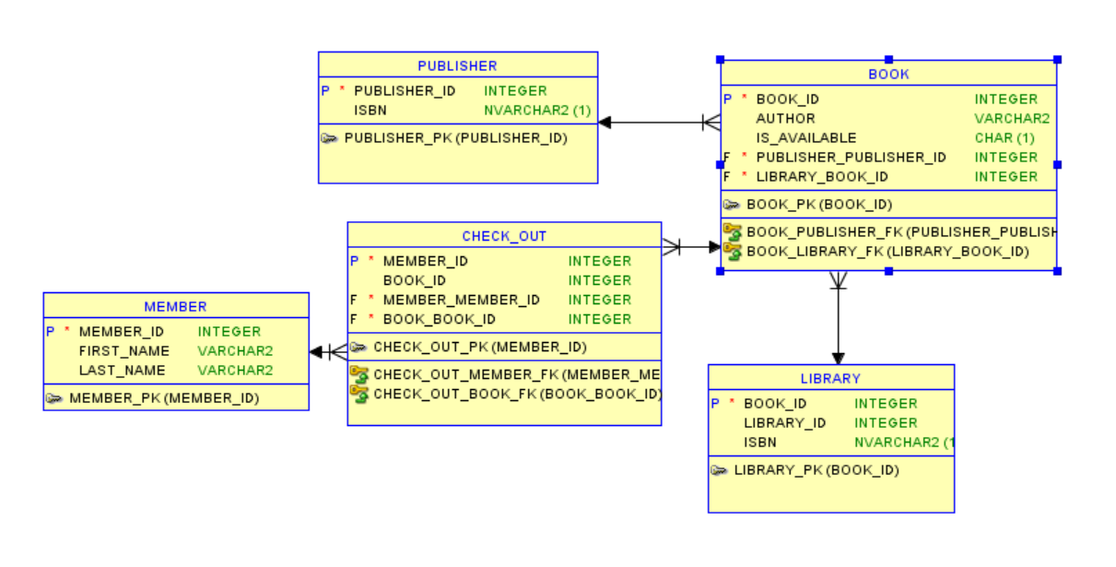

**Entities:**

* MEMBER
* PUBLISHER
* CHECK_OUT
* BOOK
* LIBRARY

**Business Rules:**

* LIBRARY store BOOK(S)
* BOOK(S) have PUBLISHER
* BOOK(S) are checked out as MEMBER

**Data Dictionary:**

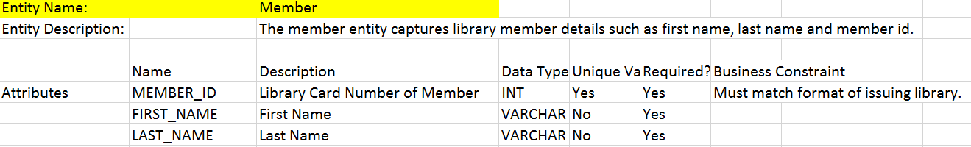

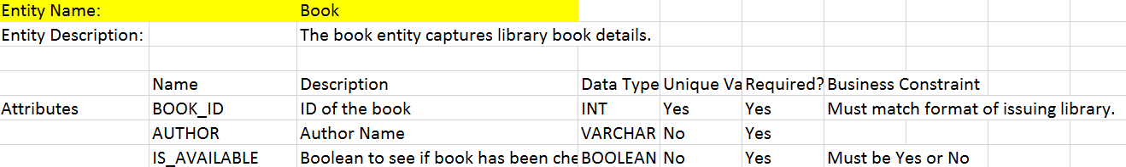

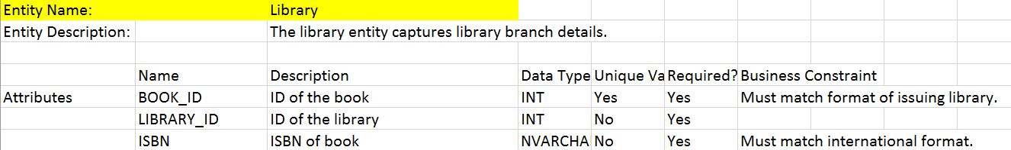

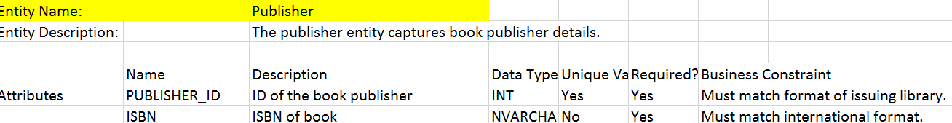

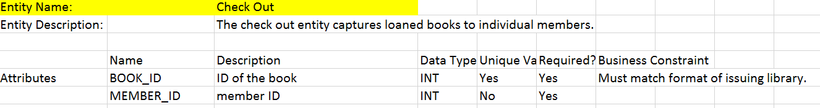

**Question #7** - Consider the material you read in this course by Bernard, Ross, and others on EA. Consider the key principles of Agile development as summarized in the Agile Manifesto – see <http://agilemanifesto.org/principles.html>. Write a short essay (< 1 page) that summarizes (1) how EA and Agile could coexist in an organization and (2) how they might work against each other. Cite specific points (i.e., short direct quotes) from both sources in your reply to this question. *(10 points, ~ ½ page)*

We live in an age where complexity is omnipresent and we have a need to be agile and transform. (Land, 2009)

Agile aims to combine rapid application development with ongoing project management. Agile is most suited for projects that require results in the immediate timeframe. Agile can be used to support ad hoc projects for integration and application development. Agile is therefore a methodology aimed to reap results in the short term. When project managers and application developers plan weekly agile sprints they focus on user stories and action items that can be tackled in the short term and reap immediate results. Agile works on the premise of excellent communication between the requirement, implementation and testing teams. Agile promotes self-paced and continuously evolving monitoring, revision and governance. However it should be noted that the scope of agile projects is to improve software development time for key components. Although the implementation of these components is tactical, we also need to keep in mind the integration of these components which should be strategic.

Enterprise Architecture combines a framework with a methodology and seeks to produce a repository of EA artifacts for governance and transformation. EA is expressed in several variations. In TOGAF 9.1 we have the architectural content metamodel combined with the architecture development method which helps create artifacts that are stored in the enterprise continuum. (Josey, 2011) We can use Agile as the development methodology to create software artifacts and interface design documentation. The benefit of EA is that it aligns the IT development effort with business goals to enable the organization strategically. EA can help utilize Agile method to not only facilitate tactical development but also maintain strategic outlook. As the agile team continuously reevaluates what is working for them they engage in a process of EA governance and improve key processes around development and testing. EA teams can be helped if agile feedback is inculcated into EA governance meetings.

In summary EA can steer an organization strategically as we implement agile method to fulfill tactical tasks and reduce development and testing times.

**Question #8** - Consider the case of a national healthcare provider – e.g., Kaiser Permanente or United Healthcare. Provide 2 *business-focused* EA principles for this type of business using the TOGAF format. Focus on the business, non-technical, objectives of that type of business – a reply that addresses technology (IT) will fail this question. Be sure to use the rationale and implications sections correctly. Be sure your implications aren't only benefits but also costs or challenges that would need to be overcome *(10 points, 1 page max)*

1. **Name:** Maximize Benefit to the Enterprise by taking organization wide information management decisions.

**Statement:** Expedient Information Management decisions are made to benefit the enterprise as a whole.

**Rationale:** Enterprise wide drivers and priorities should be adhered to rather than favoring any minority group objectives.

**Implications:**

* Kaiser Permanente needs to take decisions that are strategic and favorable for its long term national growth plans and profit bottom-line.
* Kaiser Permanente does not need to favor individual hospital locations over another unless it helps strategic objectives.
* Kaiser Permanente needs to integrate siloes of decision making into a cohesive whole that integrates the enterprise to operate nationally.

1. **Name:** Maintain Compliance with the Law and develop profile as an ethical organization.

**Statement:** The enterprise needs to operate in compliance of, privacy and federal and state coverage laws.

**Rationale:** The enterprise should operate in accordance with health standards, secure PII information in accordance with HIPPA and operate in accordance with state and federal Medicaid rules.

**Implications:**

* Kaiser Permanente should not have any legal problems that might threaten its survival.
* Kaiser Permanente should comply with health, PII, and federal aid laws.
* Kaiser Permanente should improve its ethical image by conducting pro bono clinics and offering proceeds to charities. This will help improve the organization profile as a compliant and ethical organization.

**Works Cited:**

**Cloo, J., Land, M.O., Proper, E., Steghuis, C. & Waage, M. (2009). Enterprise Architecture: Creating value from Informed Governance.Berlin:Springer.**

**Josey, A. (2011). TOGAF v9.1 Enterprise Edition- an introduction. The Open Group. 1-13.**

**Minoli, D.  (2008). Enterprise Architecture A to Z: Frameworks, business process modeling, SOA, and infrastructure technology. Boca Raton, FL: CRC Press**.

**Weber, B. (2016, Sept 29).Business Process Management Systems and Challenges in their adoption. Retrieved July 1, 2017, from https://www.fing.edu.uy/inco/eventos/bpmuy/presentaciones/pres_Weber.pdf**

**Weber, B., & Riechert, M.(2012). Enabling Flexibility in Process Aware Information Systems- Challenges, Methods, Technologies. London: Springer.**

**Zachman, J. P. (2009, April 01). The Zachman Framework Evolution by: John P. Zachman.**

**Retrieved May 17, 2017, from https://www.zachman.com/ea-articles-reference/54-the- zachman-framework-evolution**